Transpiler vs. Compiler
Both transpilers and compilers are programs that convert source code into another form. The key difference lies in the level of abstraction of the output code.
- Compiler: A compiler translates code from a high-level language (human-readable, like C++ or Java) into a low-level language (like assembly or machine code) that can be executed directly by the computer's processor. The output is not human-readable.
- Transpiler: A transpiler, a portmanteau of "translator" and "compiler," converts code from one high-level language to another high-level language. The output is still human-readable and often has a similar level of abstraction as the source code. A common use case is converting newer versions of a language (like ES6+ JavaScript) into an older, more widely supported version (ES5) to ensure compatibility with older browsers.

Memory Leaks in useEffect
Memory leaks often occur when a component unmounts but still holds a reference to an object, such as an event listener or a timer, preventing it from being garbage collected.
The useEffect hook runs after every render (by default) and is the primary place for performing side effects in React function components. If you perform an action that sets up a subscription or a side effect that needs to be cleaned up, like adding an event listener or a setTimeout function, you must provide a cleanup function to prevent memory leaks.
A common scenario for a memory leak is when a useEffect hook sets up an asynchronous operation, like an API call or a timer, and the component unmounts before that operation completes. The component is gone, but the callback for the asynchronous operation might still try to update the state of the now-unmounted component, leading to an error and a memory leak.

How to Avoid with Cleanup
To avoid memory leaks, the useEffect hook provides a mechanism to return a function. This returned function is the cleanup function, which React will run just before the component re-renders (if the dependencies change) and, more importantly, when the component unmounts.

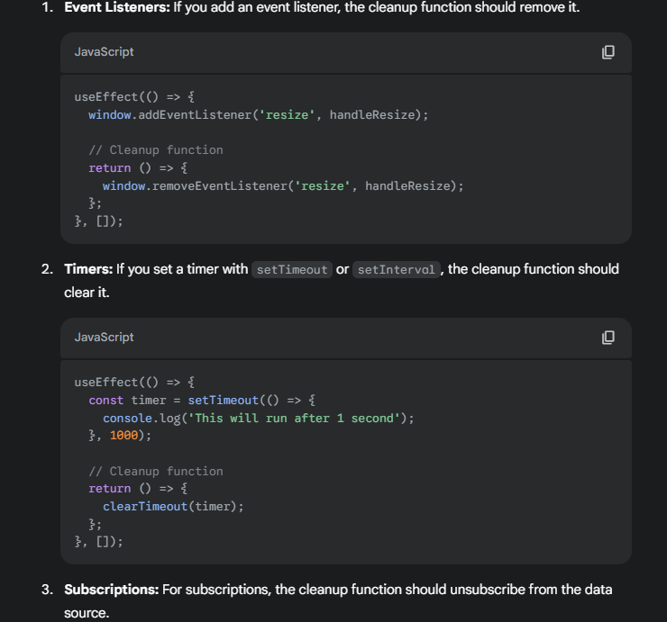
What is useCallback?
useCallback is a React Hook that memoizes a function, which means it returns a memoized version of a callback function that only changes if one of the dependencies has changed. This is useful for preventing unnecessary re-renders in child components.
Think of it like this: every time a component re-renders, any function defined inside it is re-created. If you pass this function as a prop to a child component, the child component will also re-render because it sees a new prop, even if the function's logic hasn't changed. useCallback prevents this by giving you the same function instance on every render unless a dependency changes.
When to use useCallback:
- When passing a callback to an optimized child component that uses React.memo, shouldComponentUpdate, or PureComponent.
- To avoid re-creating a function that is used as a dependency in another Hook, like useEffect, useLayoutEffect, or useCallback itself.

What is useMemo?
useMemo is a React Hook that memoizes a value. It returns a memoized value that only re-computes when one of its dependencies has changed.
Imagine you have a component that performs a complex, expensive calculation. If this calculation is done directly inside the component, it will run on every single re-render, which can be a performance bottleneck. useMemo solves this by caching the result of that calculation. The calculation will only be re-run if one of the dependencies in the dependency array changes.
When to use useMemo:
- For expensive calculations that you don't want to run on every render.
- To memoize an object, array, or other data structure that you're passing as a prop to a child component, which helps prevent unnecessary re-renders.

Key Differences:
The primary difference between useCallback and useMemo is what they memoize.
- useCallback memoizes a function. It's used when you want to prevent a function from being re-created on every render.
- useMemo memoizes a value. It's used to avoid re-calculating an expensive value on every render.

What is Prop Drilling?
Prop Drilling happens when you pass data from a parent component down to deeply nested child components via props, even though some of the middle components don’t need the data.
It becomes a problem when your component tree is deep.

What is the Context API?
The Context API is a built-in feature in React that allows you to share state (data) across the entire component tree without having to pass props manually at every level ("prop drilling").
Think of it as a global state container for your React app (not as heavy as Redux, but useful for simpler cases).
Why do we need Context API?
Normally in React, if you want to share data from a parent to deeply nested children, you have to pass props through multiple levels:
This is called prop drilling — and it quickly becomes messy.
Context API solves this problem by allowing you to share data directly without drilling.
It has 3 main parts:
- Create a Context:
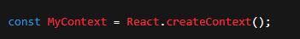

- Provide the Context (Provider):
Wrap your component tree inside a Provider and pass the data you want to share.
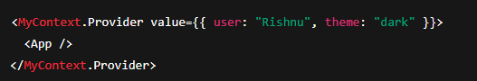
- Consume the Context (Consumer):
Access the shared data inside any child component.
Option 1: Using useContext Hook (modern way)
Option 2: Using <MyContext.Consumer> (older way)
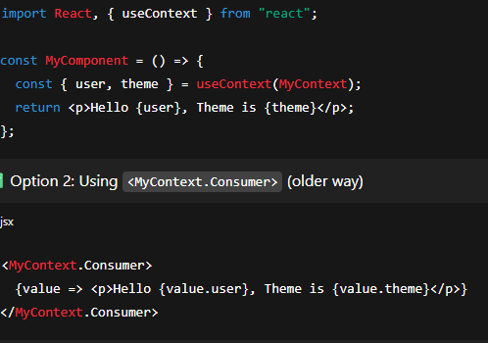
When to use Context API?
Use it when:
- You want to avoid prop drilling.
- You need global state like authentication, themes, language, or user info.
- Your app has medium complexity (for very large apps, Redux/Zustand/Recoil might be better).

What is the useContext hook?
The useContext hook is a modern way to consume context in functional components. Before hooks, developers had to use a Consumer component, which often led to nested JSX and could make the code harder to read.
The useContext hook simplifies this process by allowing you to directly access the context value from within your component. You pass the context object (the one you created with React.createContext()) as an argument to useContext, and it returns the current value of that context.

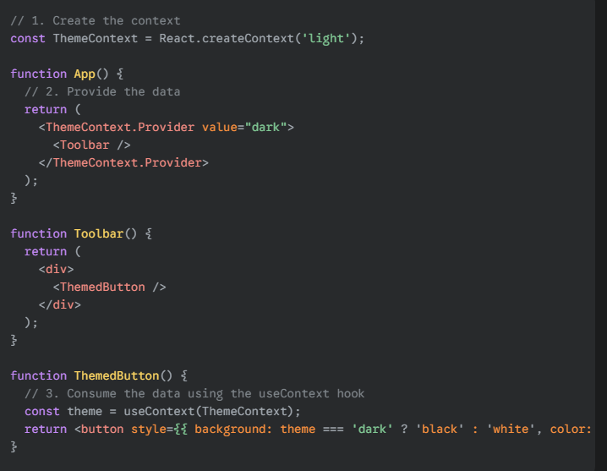
In this example, the ThemedButton component, which is nested within Toolbar, can directly access the dark value from ThemeContext without Toolbar having to pass it as a prop.
Key benefits of useContext:
- Avoids prop drilling: It eliminates the need to pass data through multiple intermediate components that don't need it.
- Simplifies code: It makes your component code cleaner and easier to read compared to using the older Consumer component pattern.
- Decouples components: It allows for a more flexible and less coupled component structure, as components can access data they need without their parents having to explicitly pass it down.

React Fiber
It is the new reconciliation engine introduced in React 16 (2017).
What is reconciliation?
Reconciliation is the process React uses to:
- Compare the Virtual DOM with the previous DOM (diffing).
- Decide what needs to be updated in the real DOM.

It is a complete rewrite of React's core reconciliation algorithm, which is the process of updating the user interface. Before Fiber, React used a synchronous, stack-based algorithm. This meant that once an update started, it couldn't be interrupted, which could cause the main thread to be blocked and lead to a slow, "janky" user experience, especially with complex animations or large updates.
Fiber's main goal is to enable incremental rendering. It breaks down the rendering work into smaller units, called "fibers," which can be paused, resumed, or even aborted. This allows React to:
- Prioritize updates: High-priority work, like a user's keyboard input or a click, can be processed immediately, while less critical work, like a data fetch update, can be deferred.
- Time-slice the work: React can spread the rendering work across multiple frames, preventing it from blocking the browser's main thread and keeping the UI responsive.
- Support new features: Fiber's architecture paved the way for features like Suspense (for data fetching) and Error Boundaries (for gracefully handling errors in the component tree).
In essence, Fiber makes React's rendering process more flexible and performant, particularly for dynamic and complex applications.

Axios Interceptors
Axios is a promise-based HTTP client for making API requests.
Interceptors in Axios are functions that run before a request is sent or after a response is received.
They are like middleware for your API calls.
Types of Interceptors
- Request Interceptors → Modify request before sending.
Example: add authentication tokens, log requests.
- Response Interceptors → Handle responses before they reach your code.
Example: refresh expired tokens, handle errors globally.

Why use Axios Interceptors?
- Add auth tokens automatically to requests.
- Handle global errors in one place (like 401, 500).
- Log requests/responses for debugging.
- Transform request/response data before passing to your app.

What is Diffing Algorithm?
The Diffing Algorithm is the method React uses to efficiently compare the Virtual DOM (new tree) with the previous Virtual DOM (old tree) in order to update only the parts of the real DOM that changed.
Without it, React would re-render the entire DOM tree, which is very slow.
So instead, React finds the minimal set of changes and updates only those.

Why is it needed?
- Updating the entire DOM on every change is expensive.
- Example: Imagine a 1000-row table where only one row changes → React should update only that row, not re-render the entire table.
- Diffing algorithm makes React’s updates fast & efficient.

Higher Order Component (HOC)?
A Higher Order Component (HOC) is an advanced React pattern where you take a component as input and return a new component with extra props, logic, or behaviour.
In simple terms:
HOC = Function that takes a component and returns a new component.
Why use HOCs?
- To reuse logic across multiple components.
- To add extra features (like authentication, logging, API calls) without rewriting code.
- To keep components clean and focused on rendering.
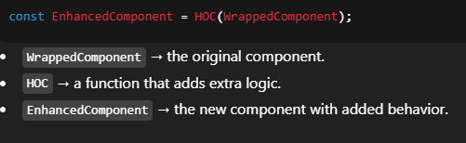
Rules of HOCs
- Don’t modify the original component – always return a new one.
- Pass props through → use {...props} to ensure original props aren’t lost.
- Pure function → HOCs should not change component behaviour unexpectedly.

Profiler in React
The Profiler is a React built-in component (introduced in React 16.9) that helps developers measure the performance of rendering in React applications.
Think of it as a performance tracker that tells you:
- How often a component renders.
- How long each render takes.
- Why a render happened (re-renders due to props, state, context).

Why use Profiler?
- To find performance bottlenecks.
- To detect unnecessary re-renders.
- To measure the impact of changes in state/props.
This is especially useful in large apps where components re-render frequently.

How to use Profiler
React provides a <Profiler> component that wraps around parts of your app.
It accepts:
- A id (string identifier).
- An onRender callback function that gets called after each render.
Real-world uses
- Measure performance of expensive components (tables, charts, lists).
- Detect unnecessary re-renders (maybe a child renders when parent updates even if props didn’t change).
- Compare before & after optimization results (e.g., before using React.memo, after).

Lazy Loading
Lazy loading is a design pattern where some part of your application (like components, images, or data) is loaded only when it is needed, instead of at the initial page load.
Goal: Improve performance by reducing initial load time and loading heavy resources on demand.
In React, lazy loading is mostly used for components to split the bundle into smaller chunks (code splitting).
Instead of loading the entire app at once, React loads only what’s required for the current view, and other parts are loaded on demand.
How to Implement Lazy Loading Components
React provides:
- React.lazy() → for dynamically importing a component.
- Suspense → to show a fallback (like a loader) while the component is being loaded.
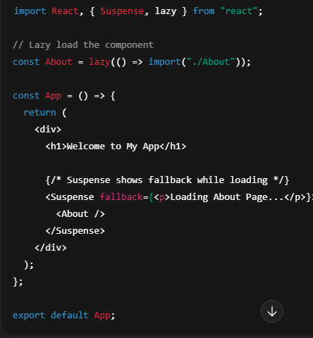
Behavior:
- When the app loads → only main App code loads.
- When About is needed → React loads it asynchronously.

Benefits of Lazy Loading
- Faster initial load (less JS & images upfront).
- Reduced bundle size (code splitting).
- Better performance on slow networks.

When to use Lazy Loading
- Large components/pages (e.g., dashboards, charts, maps).
- Routes/pages that are not needed immediately.
- Images, videos, or heavy media.
- What are Synthetic Events?
- In React, Synthetic Events are wrapper objects around the browser’s native events.
They work as a cross-browser abstraction of events, so you don’t have to worry about browser inconsistencies (like differences between Chrome, Firefox, IE, etc.).
- In simple words:
- Synthetic Events = React’s way of handling events that look like normal browser events but work the same across all browsers.
Why does React use Synthetic Events?
- Cross-browser compatibility → Same API across browsers.
- Performance optimization → React uses event delegation (attaches one listener at the root instead of many per element).
- Pooling system (before React 17) → React reused event objects for performance.
  - After React 17, event pooling was removed (now you don’t need event.persist()).
Common Synthetic Events
React normalizes many DOM events under Synthetic Events, like:
- onClick
- onChange
- onSubmit
- onKeyDown, onKeyUp
- onMouseEnter, onMouseLeave
- onFocus, onBlur
- onScroll

Ways to Improve React Application Performance

- Use React.memo to prevent unnecessary re-renders
- React.memo prevents a component from re-rendering if its props haven’t changed.
- Use useCallback and useMemo
- useCallback → memoizes functions so they aren’t recreated on every render.
- useMemo → memoizes expensive calculations.

3. Code Splitting & Lazy Loading
• Load only what’s needed using React.lazy + Suspense.
• Use dynamic imports for components/pages.
4. Avoid Anonymous Functions in JSX
5. Use Pagination & Infinite Scroll for Large Lists
- Don’t render 1000+ items at once.
- Use libraries like react-window or react-virtualized for list virtualization
6. Use Production Build
- Development build of React is slower.
- Always run:
npm run build
and deploy production bundle
7. Optimize Images & Media
- Use loading="lazy" for images.
- Compress images (e.g., WebP).
- Use CDN for assets.

